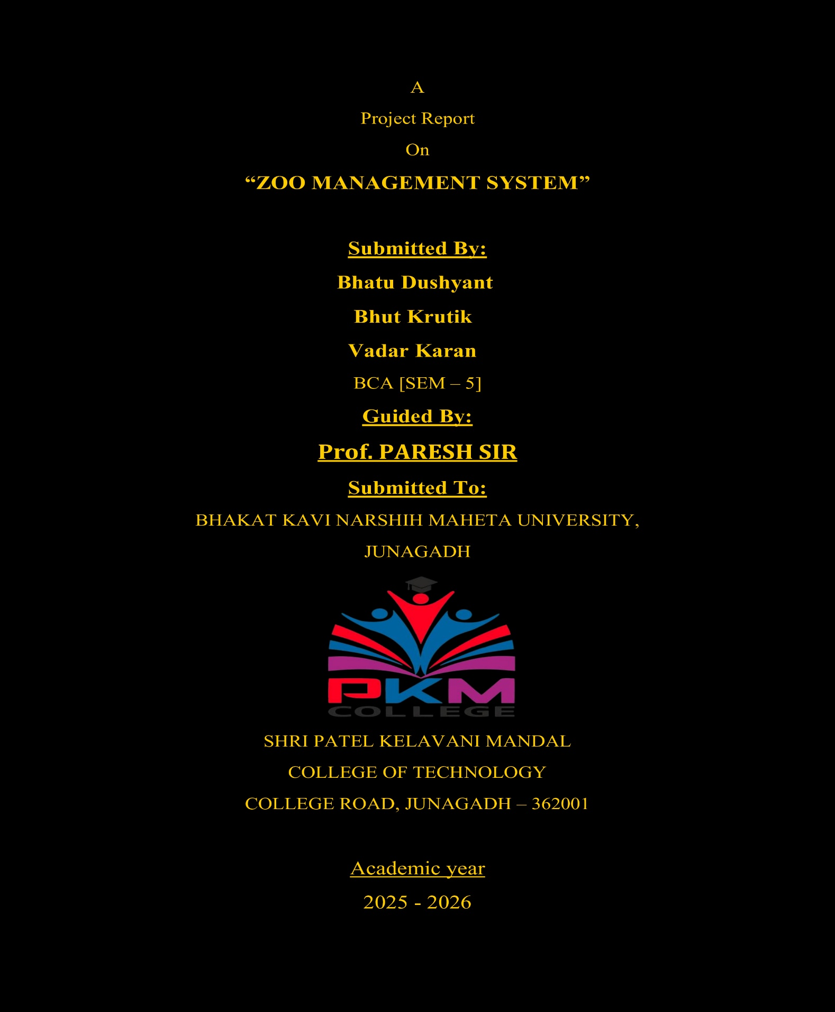



TOUR PACKAGE BOOKING SYSTEM

BCA SEM

-

5

**+++**

**KNKFJGOFIJHJGITUYH**

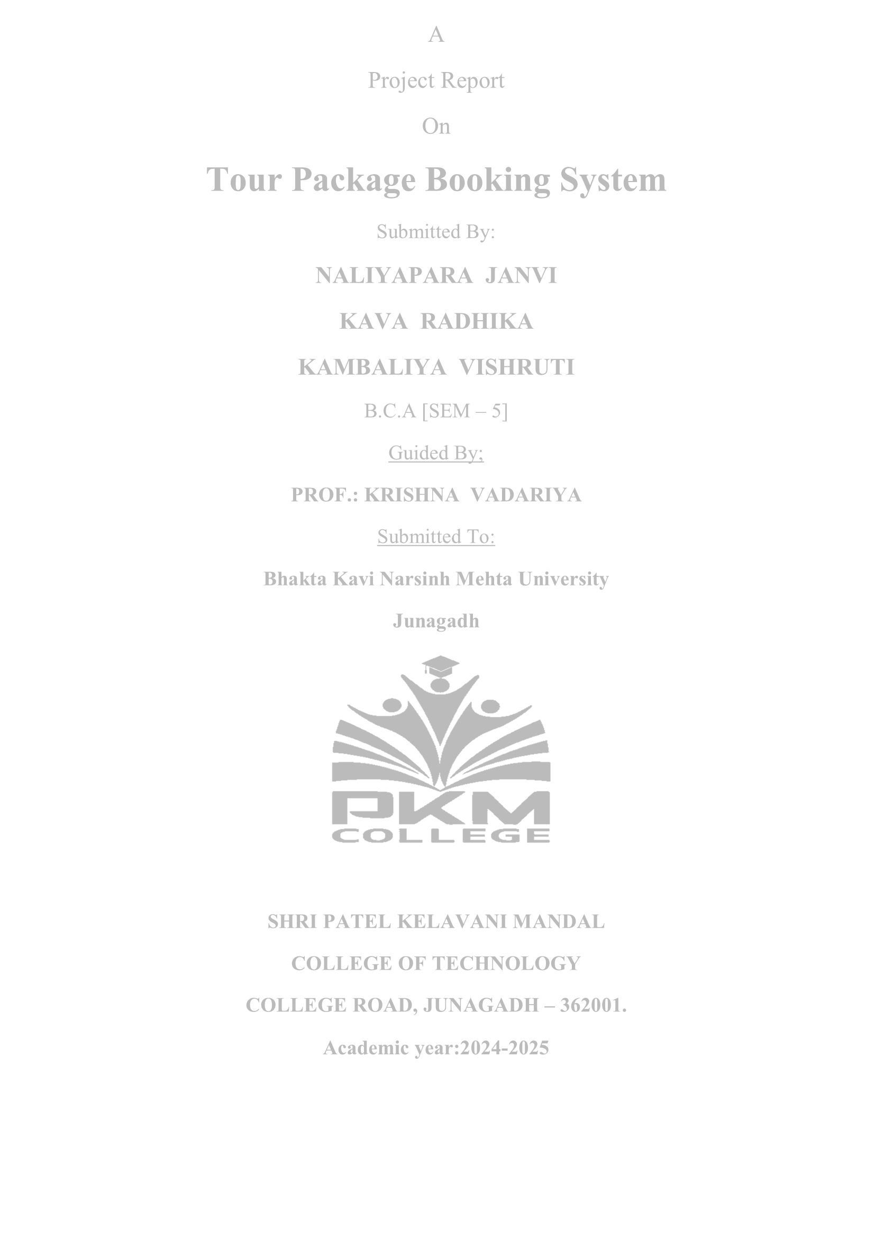

A

Project Report

On

**APPS STORE**

Submitted By:

**MANDAVIYA**

**ANKIT**

**BHALANI JENISH**

**KINDERKHEDIYA VASU**

B.C.A [SEM

–

5]

Guided By;

**PROF.:**

**KRISHNA**

**VADARIYA**

Submitted

To:

**Bhakta Kavi Narsinh Mehta University**

**Junagadh**



**SHRI PATEL KELAVANI MANDAL**

**COLLEGE OF TECHNOLOGY**

**COLLEGE ROAD, JUNAGADH**

**–**

**362001.**

**Academic year:202**

**5**

**--**

**2026**

#  ABSTRACT:-

“APPS STORE” was taken by me and my project partner our 5th Semester for B.C.A. at PKM COLLEGE JUNAGADH under Bhakt Kavi Narsinh Mehta University.

I am deeply grateful to the persons who are directly or indirectly involved with this project and who have help helped me completing this project successfully.

First of all I am grateful to my project guide **Prof. Krishna Mem** who has guide me through the project. Their encouragement guidance helped me to take this kind of live project and complete it by the time.

My other classmates who inspired me and my friends who gave me valuable suggestions are also part of my project work.

And last but not the least, my family members who supported me through my study, helped me immensely in the project also.

I am thankful to Shree P.K.M. College for all the facilities they provide me. And I would like to thanks all staff members of my college.

**Mandaviya Ankit**

**Bhalani Jenish**

**Kinderkhediya Vasu**

* **ACKNOWLEDGMENT:-**

We sincere “THANKS” goes to:

We have thankful to all people to contribute in this project. And also thanks to this people to helpful us. We would like to thank those without whose support and inspiration this project is not successfully accomplished. We have first of all thanks to our guide **Prof. Krishna Vadariya** who took us in the right path for the web application development and they have been also provided the suggestion and advices. We are also thanks to our head of department **Prof. Nilam Katharotia** they are given us to knowledge about the good software developer.

We are also very thankful to respective principal who gave us an opportunity to present this project.

* **DECLARATION:-**

We **MANDAVIYA ANKIT , BHALANI**

**JENISH, KINDERKHEDIYA VASU** student of

B.C.A. In Shree Patel Kelavani Mandal College of technology and B.ED. would like to declare that the project report entitled **“PKM COLLEGE”** submitted by using partial Fulfilment of the requirement of the completion of B.C.A. SEM-5 is my original work.

1._________

2._________

3._________

(Student Signature)

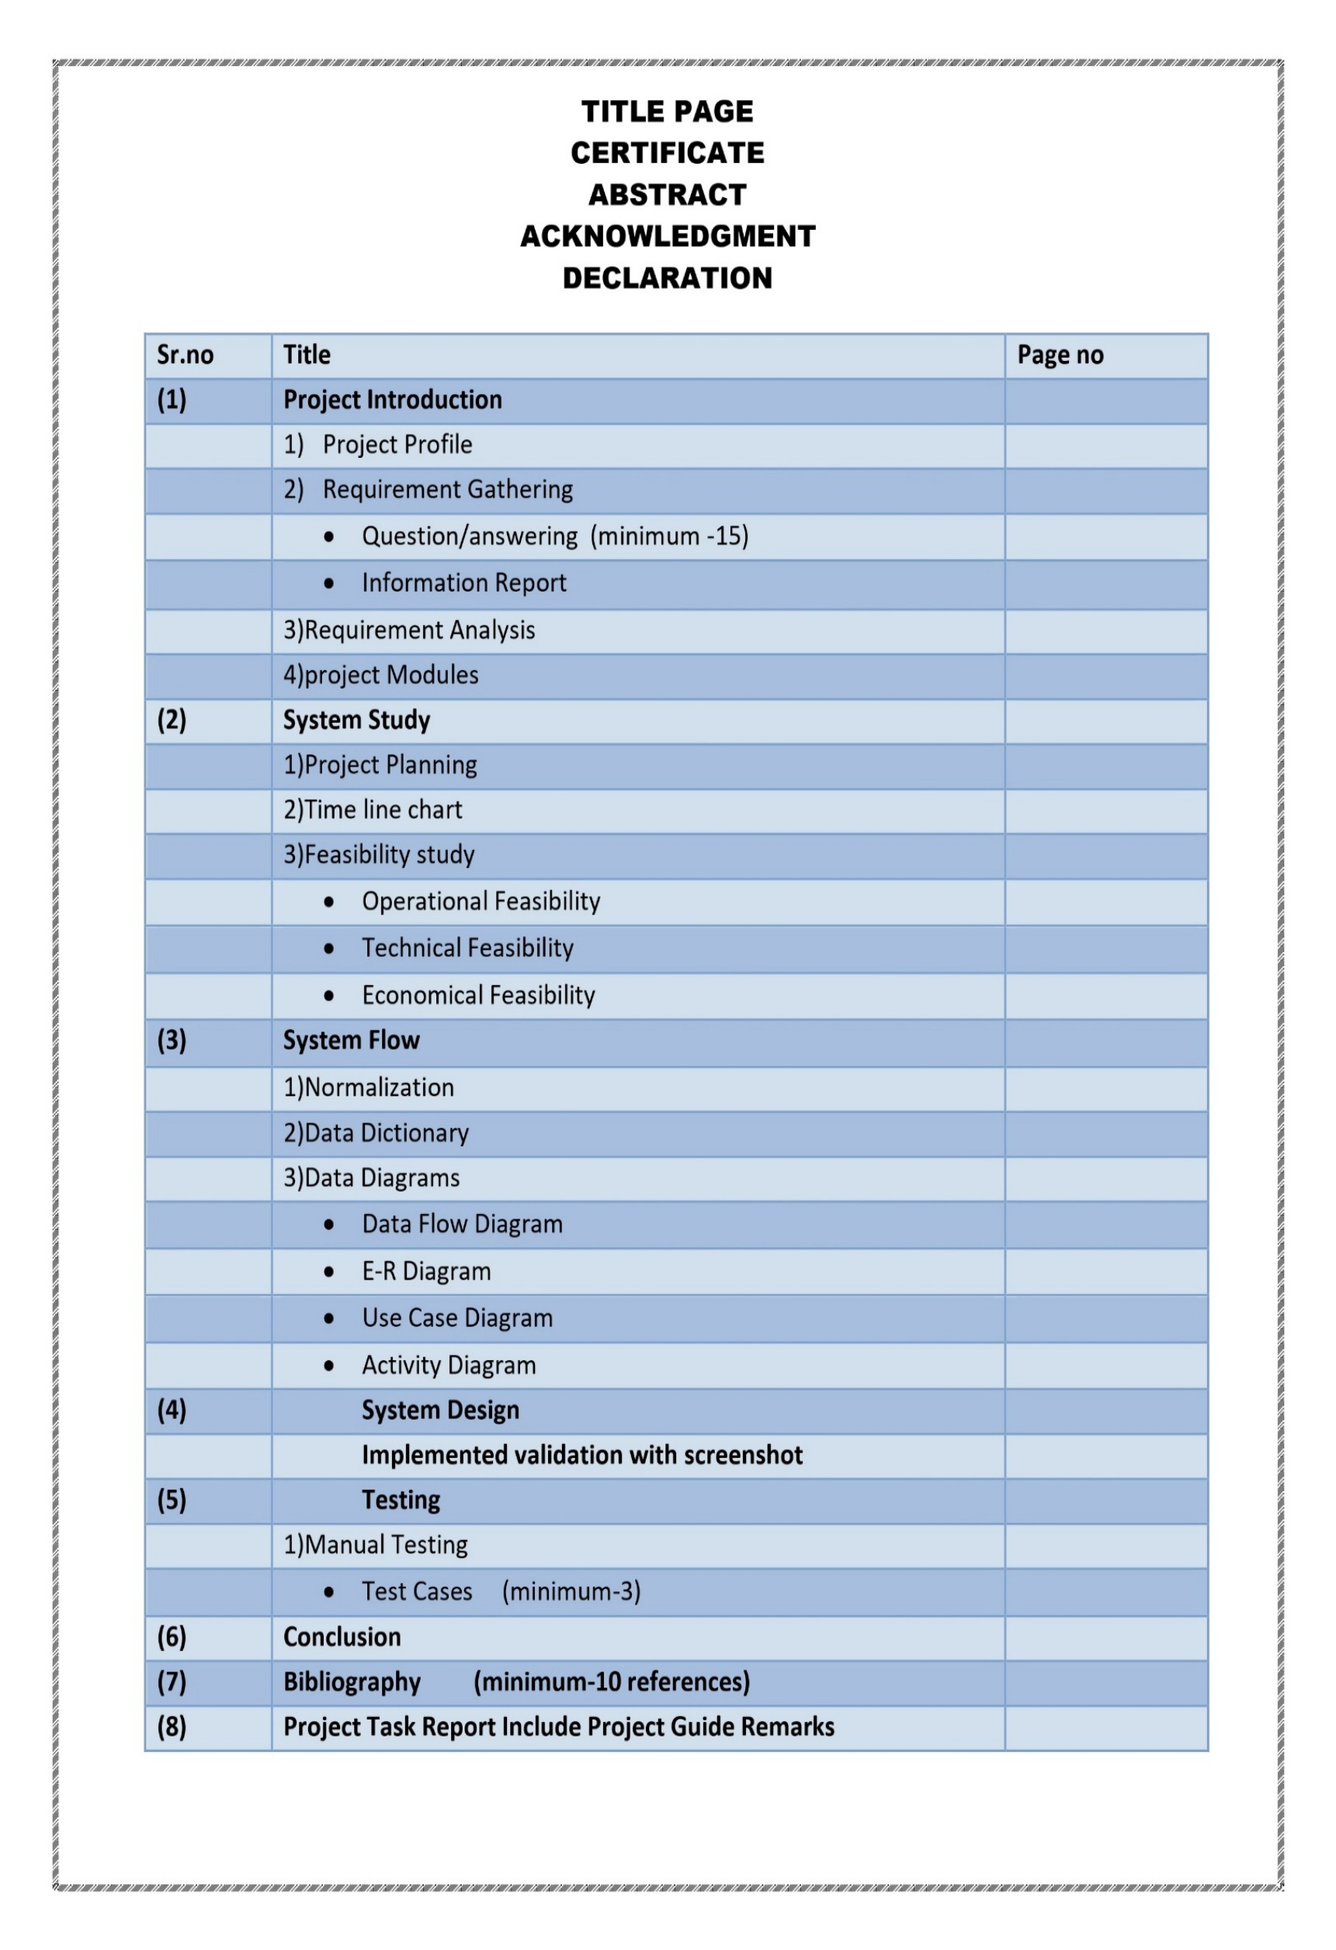

##  PROJECT INTRODUCTION:-

* The “APPTUBE” is an APP & GAME store site script where user will be able to browser view details , and download various apps and platform , user can Explore apps across multiple categories like education Entertainment , games , and more.
* User can also register , login to create there profile to download apps & games
* The platform include safe download links , app information , and a smooth , friendly interface for an enhanced user experience
* The main aim of APPTUBE is to provide user with a simple safe , and user- friendly platform to discover and download app and games all in one place

1

##  PROJECT PROFILE:-

|  |  |
| --- | --- |
| **Project Title** | **“GET_GO_TRIP”** |
| **Project Description** | **Apptube is apps & games downloading site script where site user view different categories apps & games and also can download** |
| **Project Duration** | **3 Months.** |
| **Project Guide** | **Prof. Krishna mem** |
| **Platform** | **Application will be embedded with windows 11 and deployed with vs code** |
| **Tool Used** | **1. Editor Use:- Visual Studio Code**  **2.Web Server:- MySQL**  **3.Browser:- Google Chrome, Firefox** |
| **Front End** | **HTML , CSS , JAVA** |
| **Back End** | **NODE JS** |
| **Team Member** | **3** |
| **Name of Team Members** | **1.Madaviya Ankit**  **2.Bhalani Jenish**  **3.Kinderkhediya Vasu** |

2

##  Requirement Gathering:-

* “In this phase of SDLC necessary information is collected we have collected information in this phase of our project development though different web sites”.
* “Requirement gathering is the most important and fundamental stage in **SDLC**”.
* There are mainly four types of requirement gathering

|  |  |
| --- | --- |
| **A** | **Interviews** |
| **B** | **Questionaries** |
| **C** | **Record Reviews** |
| **D** | **Observation** |

* But we choose Questionnaires option.
* Above four types we choose “Questionaries”.

###  QUESTIONNARIES:-

* Questionaries are special purpose document that allow the analyst to collect information and options from respond by using from respondent by above four types we choose “Questionaries”.

* **Questions:-**

1) **What is Apptube?**

* + It Is a website where user aim downloads apps & games.

1. **Which Technologies are used in Apptube ?**
   * Html , CSS , JavaScript , ndode.js and MySQL
2. **What can user do on Apptube ?**
   * User can browse , view , and download apps and games.
3. **Can user upload apps ?**
   * Only the admin can upload app and games in the website.
4. **Where are app file stored ?** 
   * App icons and apps files are stored in database.
5. **How Are user authenticated ?** 
   * Using login with secure Password hashing and Sessions

**7)** **What type of apps are available ?**

* + Apps are available in different categories like education , Entertainment , games etc.

1. **Is There a search feature ?**

• Yes user can search app by name or category.

1. **Does Apptube have an admin Panek ?**

• Yes for managing apps , user and categories.

1. **What is the aim of Apptube ?**
   * To provide a safe and easy Platform to download app and games.

* + - **INFORMATION REPORT:-**

* + - Existing system & requirement of new system:
    - In the existing system all Windows app and game sharing is done manually , which is time – consuming.

No proper platform exits to download verified windows app or tools in a categorized format.

* + - Files are shared via third-party links or usb , which may not be safe or updated.
    - Need for a new system is clear due to lack of security organization , and automation.

**⮚ New System :-**

* + - Apptube allows user to register log in and securely view and download windows app and games.
    - App are reviewed via an admin panel before being made public
    - Categories , search and filters make navigation simple and helpful.
    - Maintains app details like version , size , developer info , etc
    - Helpful for student developers and user in sharing and discovering apps easily

###  REQUOREMENT ANALYSIS:-

• Requirement analysis is one of the most important phases in the life cycle of the software development, In requirement analysis the developer should know the requirements of the user and all the facilities they needed.

|  |  |
| --- | --- |
| **ADMIN** | **Client** |
| **Login** | **Login** |
| **Add Category** | **Registration** |
| **Add app & games** | **View app & games download** |
| **Manage user** | **Download** |
| **Manage Contact** | **View category** |
| **Logout** | **Contact us**  **About us**  **Visit our social – media** |

❖ **PROJECT MODULE:-**

* **ADMIN:-**

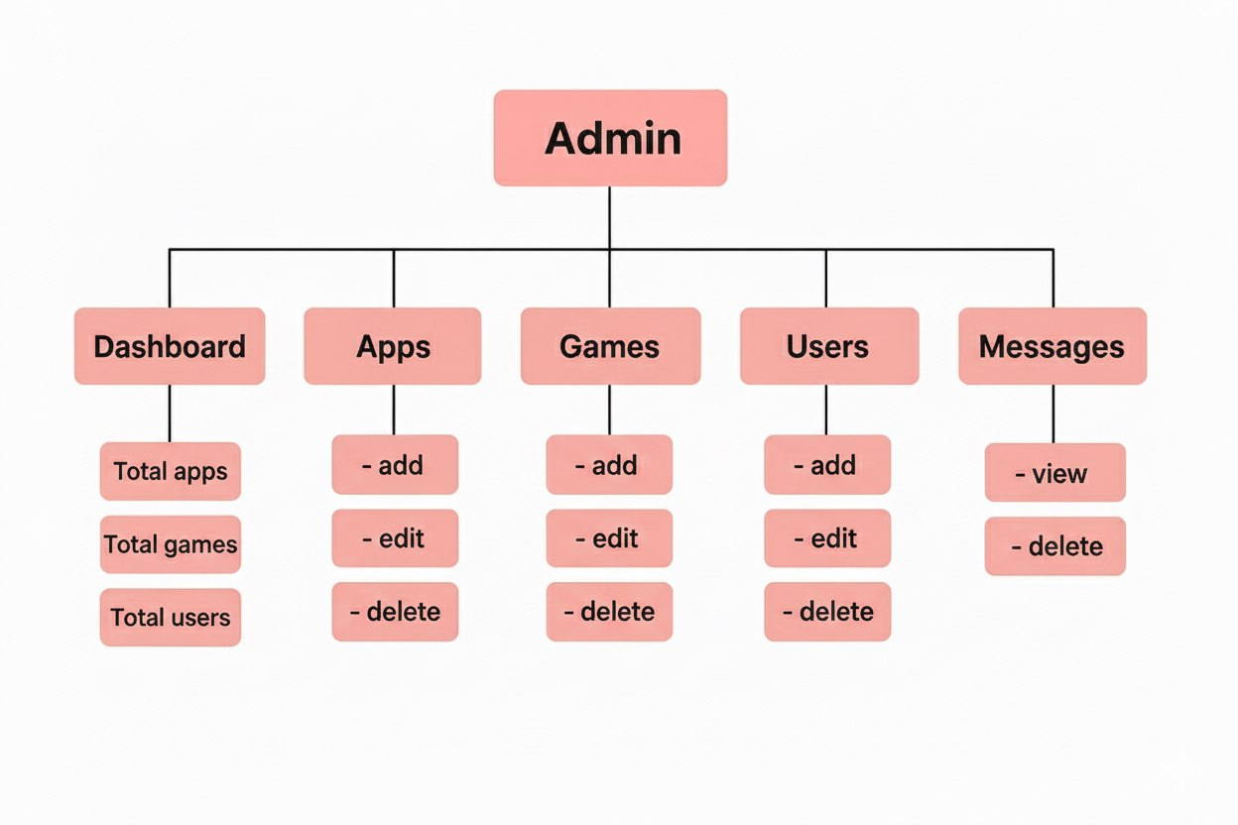

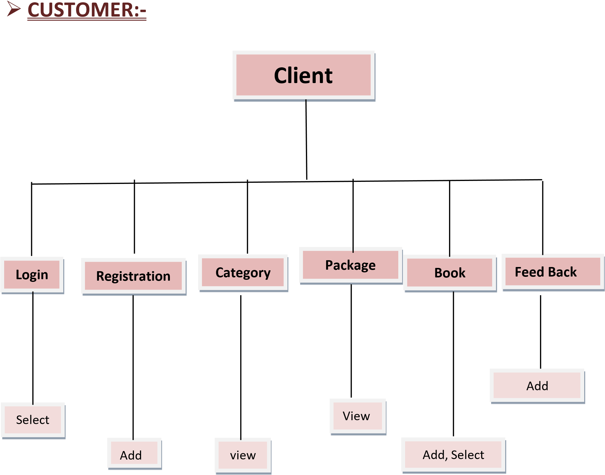

* + **SYSTEM STUDY:-**

* **PROJECT PLANNING:-**

|  |  |  |  |
| --- | --- | --- | --- |
| **No.** | **Task** | **Starting Date** | **End Date** |
| **1.** | Requirement Gathering | **01-07-2024** | **15-07-2024** |
| **2.** | Analysis | **16-07-2024** | **22-07-2024** |
| **3.** | Database Design | **23-07-2024** | **28-07-2024** |
| **4.** | System Design & Coding | **29-07-2024** | **29-08-2024** |
| **5.** | Testing | **30-08-2024** | **10-09-2024** |
| **6.** | Documentation | **11-09-2024** | **25-09-2024** |

* **TIME LINE CHART:-**

|  |  |  |  |  |  |  |  |  |  |  |  |
| --- | --- | --- | --- | --- | --- | --- | --- | --- | --- | --- | --- |
| Task Name | Start | Finish | Duration | **Jul Aug** **Sep** **2024 2024 2024** | | | | | | | **Oct 2024** |
| Requirement Gathering | **01-07-2024** | **15-07-2024** | **15 DAYS** |  |  |  | | | | |  |
| Analysis | **16-07-2024** | **22-07-2024** | **7 DAYS** |  | |  |  | | | |  |
| Database Design | **23-07-2024** | **28-07-2024** | **6 DAYS** |  | | |  |  | | |  |
| System Design & Coding | **29-07-2024** | **29-08-2024** | **32 DAYS** |  | | | |  |  | |  |
| Testing | **30-08-2024** | **10-09-2024** | **12 DAYS** |  | | | | |  |  |  |
| Documentatio  n | **11-09-2024** | **25-09-2024** | **15 DAYS** |  | | | | | |  |  |
|  |

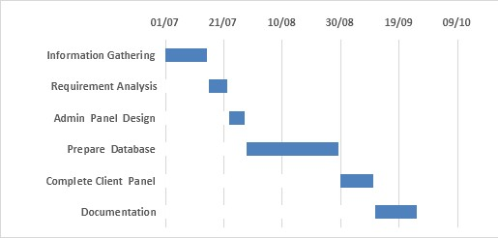

* + **FEASIBILITY STUDY:-**

* A feasibility analysis usually involves a through assessment of the operational(need), financial and technical aspects of a proposal.
* The feasibility study concluded that the project would be able to be implemented to success as it was carefully planned.
* **There are three type of feasibility…..**

**1.Operational Feasibility**

**2.Technical Feasibility**

**3.Economical Feasibility**

**1) Operational Feasibility:-**

* Whether the problem can be solved in the users’ environment with existing and proposed system workings.
* **User:-** User, Admi

####  Function that Preformed by Admin

|  |  |  |  |
| --- | --- | --- | --- |
| **Page** | **Process** | **Effected table** | **Operations** |
| **Login** | Admin login | login | Edit, view, Delete |
| **Registration** | Manage added user | User info | Delete, view |
| **Category** | Manage categories | Category | Edit, Delete , view |
| **App & Games** | Manage Apps & Games | App & Games | Add , Edit , Delete |
| **Contact us** | View & Delete | Contact us | View, Delete |

####  Function that Preformed by Customer

|  |  |  |  |
| --- | --- | --- | --- |
| **Page** | **Process** | **Effected table** | **Operations** |
| **Login** | User Login | User info | Select |
| **Registration** | New Registration | Login | Insert |
| **Category** | View Categories | Category | View |
| **Apps & Games** | View & download Apps & games | Book | View . Download |
| **About us** | View social media | Book | View |
| **Social Media** | View Social Media |  | View |
| **Contact us** | Submit queries or feedback | Cart | Insert |

**2) Technical Feasibility:-**

• Weather it is technical possible with the existing technology or with the planned new technology.

* **Hardware & Software Specification.**

* + - * **Minimum Hardware Requirement:-**

|  |  |
| --- | --- |
| **COMPONENT** | **MINUMUM REQUIREMENT** |
| Processor | Intel i3(2.0ghz) or better |
| Supported Architecture | 64 – bit only |
| Memory | 4gb or more |
| Hard disk | 250gb(20gb free for installation) |

* + - * **Minimum Software Requirement:-**

|  |  |
| --- | --- |
| **COMPONENT** | **MINIMUM REQUIREMENT** |
| Operating System | Windows 11 / Linux |
| Web Server | MySQL |
| Database | MySQL |
| Web browsers | Google chrome , Mozilla Firefox , as above |
| Backend | Node js |

**3)Economical Feasibility:-**

* + The purpose of an economic feasibility is to determine the net benefit of the project.

* + - * + **Hardware economical study**

|  |  |  |  |
| --- | --- | --- | --- |
| Component Minimum requirement | | Price Website/Shop | |
| **Processor** | Intel i3 or equivalent | 799 | [www.flipcart.com](http://www.flipcart.com/) |
| **Hard Disk** | 150GB | 1815 | [www.hardware.in](http://www.hardware.in/) |
| **Memory** | 4GB DDR3 RAM | 717 | www.hardware.com |

* + - * + **Software economical study**

|  |  |  |
| --- | --- | --- |
| **Component** **Price** | | **Website/Shop** |
| **Node js** | **FREE** | [**www.shoponline.com**](http://www.shoponline.com/) |
| **MYSQL** | **FREE** | [**www.wampserver.com**](http://www.wampserver.com/) |
| **Vs Code** | **FREE** | [**www.apachefriends.org**](http://www.apachefriends.org/) |
| **Google Chrome** | **FREE** | **www.mozila.org** |
| **MySQL to store apps** | **FREE** | [**www.google.com**](http://www.google.com/) |

* + - * + **SYSTEM FLOW:-**
        + **NORMALIZATION:-**

* + **What is Normalization?** 
    - “Database Normalization is the process of organization the columns and tables of a relational database to minimize data redundancy.”
    - Normalization usually involves dividing a database in to two or more tables and defining relationship between the tables  **First Normalization:-**

* + A database is in first normal form. If it satisfies the following conditions:
  + Contains only automatic values and there are no repeating groups

* **Attributes for Login, Registration, Order, Contact Payment tables.**

**Id**

**FName**

**LName**

**Email**

**Password**

**stat**

 **Second Normalization:-**

* A database is a second normalization form if it satisfies the following condition.
* It is in first normal form.
* All non-key attributes are fully functional dependent on primary key.

|  |
| --- |
| **Apps** |
| **ID** |
| **App Name** |
| **App type** |
| **Categories** |
| **Description** |
| **Appicon** |
| **Zipfille** |

|  |
| --- |
| **Contact** |
| **User ID** |
| **First Name** |
| **Last Name** |
| **Email** |
| **Message** |

###  DATA DICTIONARY:-

“A Data Dictionary defines the structure of the database itself and is used in control and maintenance of large database”.

* **Apps :-**

|  |  |  |
| --- | --- | --- |
| **Column** | **Type** | **Null** |
| **Id(primary)** | Int | **No** |
| **App name** | varchar(50) | **yes** |
| **App Type** | varchar(6) | **Yes** |
| **Categories** | varchar(50) | **Yes** |
| **Description** | Long text | **yes** |
| **Appicon** | Long text | **yes** |
| **Zipfile** | Long text | **yes** |

* **User :-**

|  |  |  |
| --- | --- | --- |
| **Column** | **Type** | **Null** |
| **ID(primary)** | Int | **No** |
| **First Name** | Varchar(30) | **Yes** |
| **Last Name** | Varchar(30) | **Yes** |
| **Email** | Varchar(225) | **Yes** |
| **Password** | Long text | **Yes** |

  

#### ➢ Package:- 

|  |  |  |
| --- | --- | --- |
| **Column** | **Type** | **Null** |
| **User id *(Primary)*** | Int | **No** |
| **First Name** | varchar(30) | **Yes** |
| **Last Name** | Varchar(30) | **Yes** |
| **Email** | Varchar(225) | **Yes** |
| **Password** | Long text | **Yes** |

* + **DATA DIAGRAMS**

* + **0 LEVEL DFD**

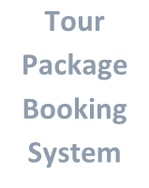

**App Games**

**Games**

**Downloading**

**Sites**

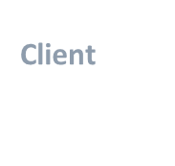

**User U**

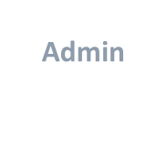

**Admin**

* + **ADMIN level DFD:-**

-`

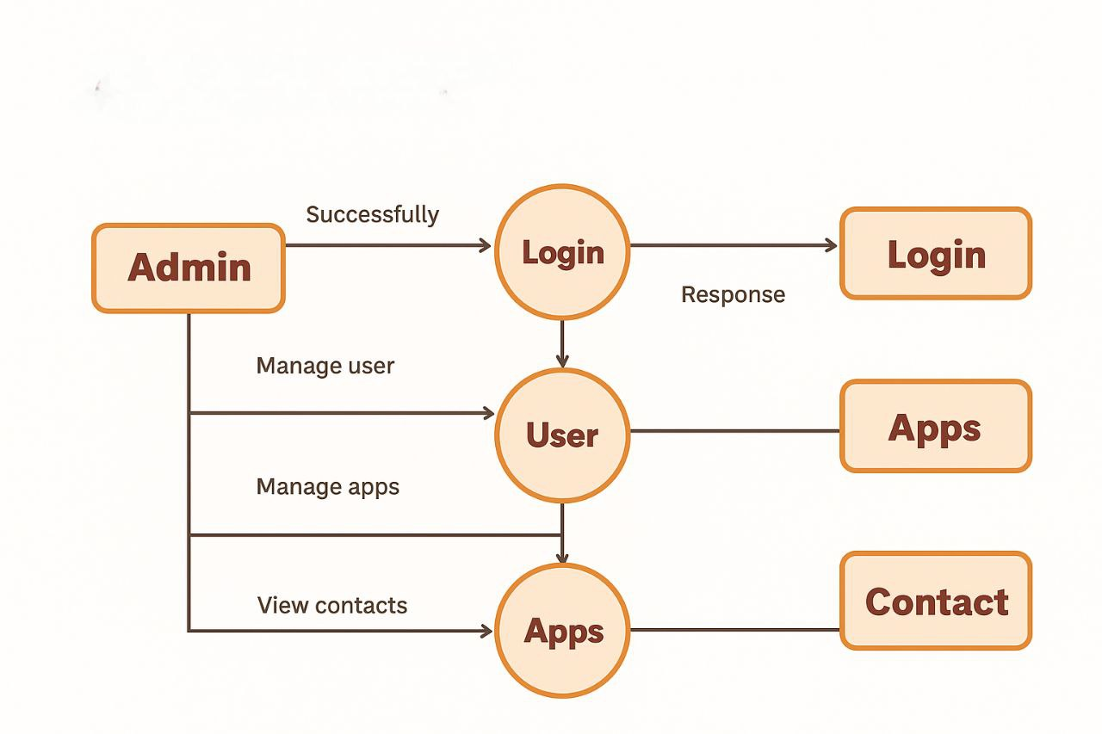

* + **User level DFD:-**

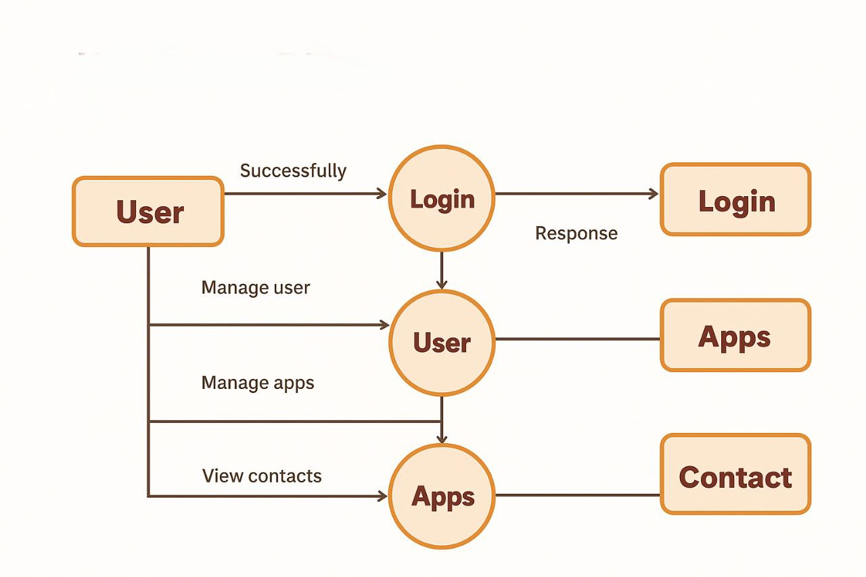

* + **E-R DIAGRAM:-**

# ➢ Entity Relationship diagram

“An E-R Diagram is a chart that a visually represents the relationship between database entities”.

**Flow Line**



**Relationship**



**Attribute**

**Entity**



❖ **E-R DIAGRAM:-**

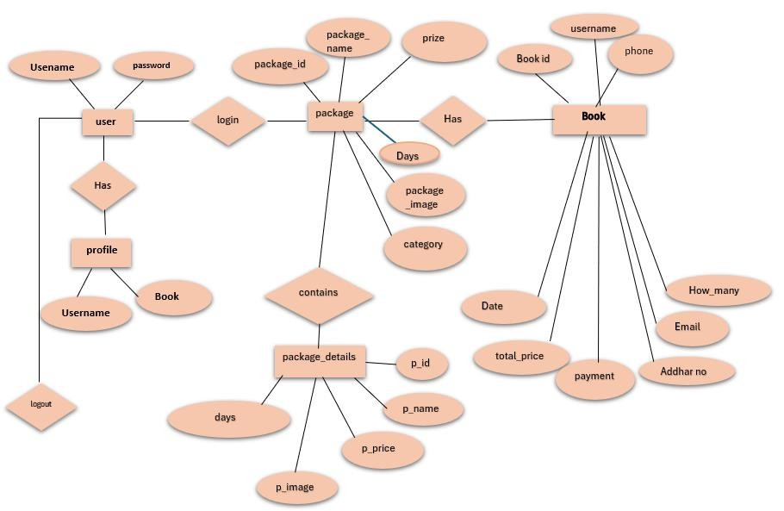

##  USECASE FOR

➢ **USECASE FOR ADMIN:-**

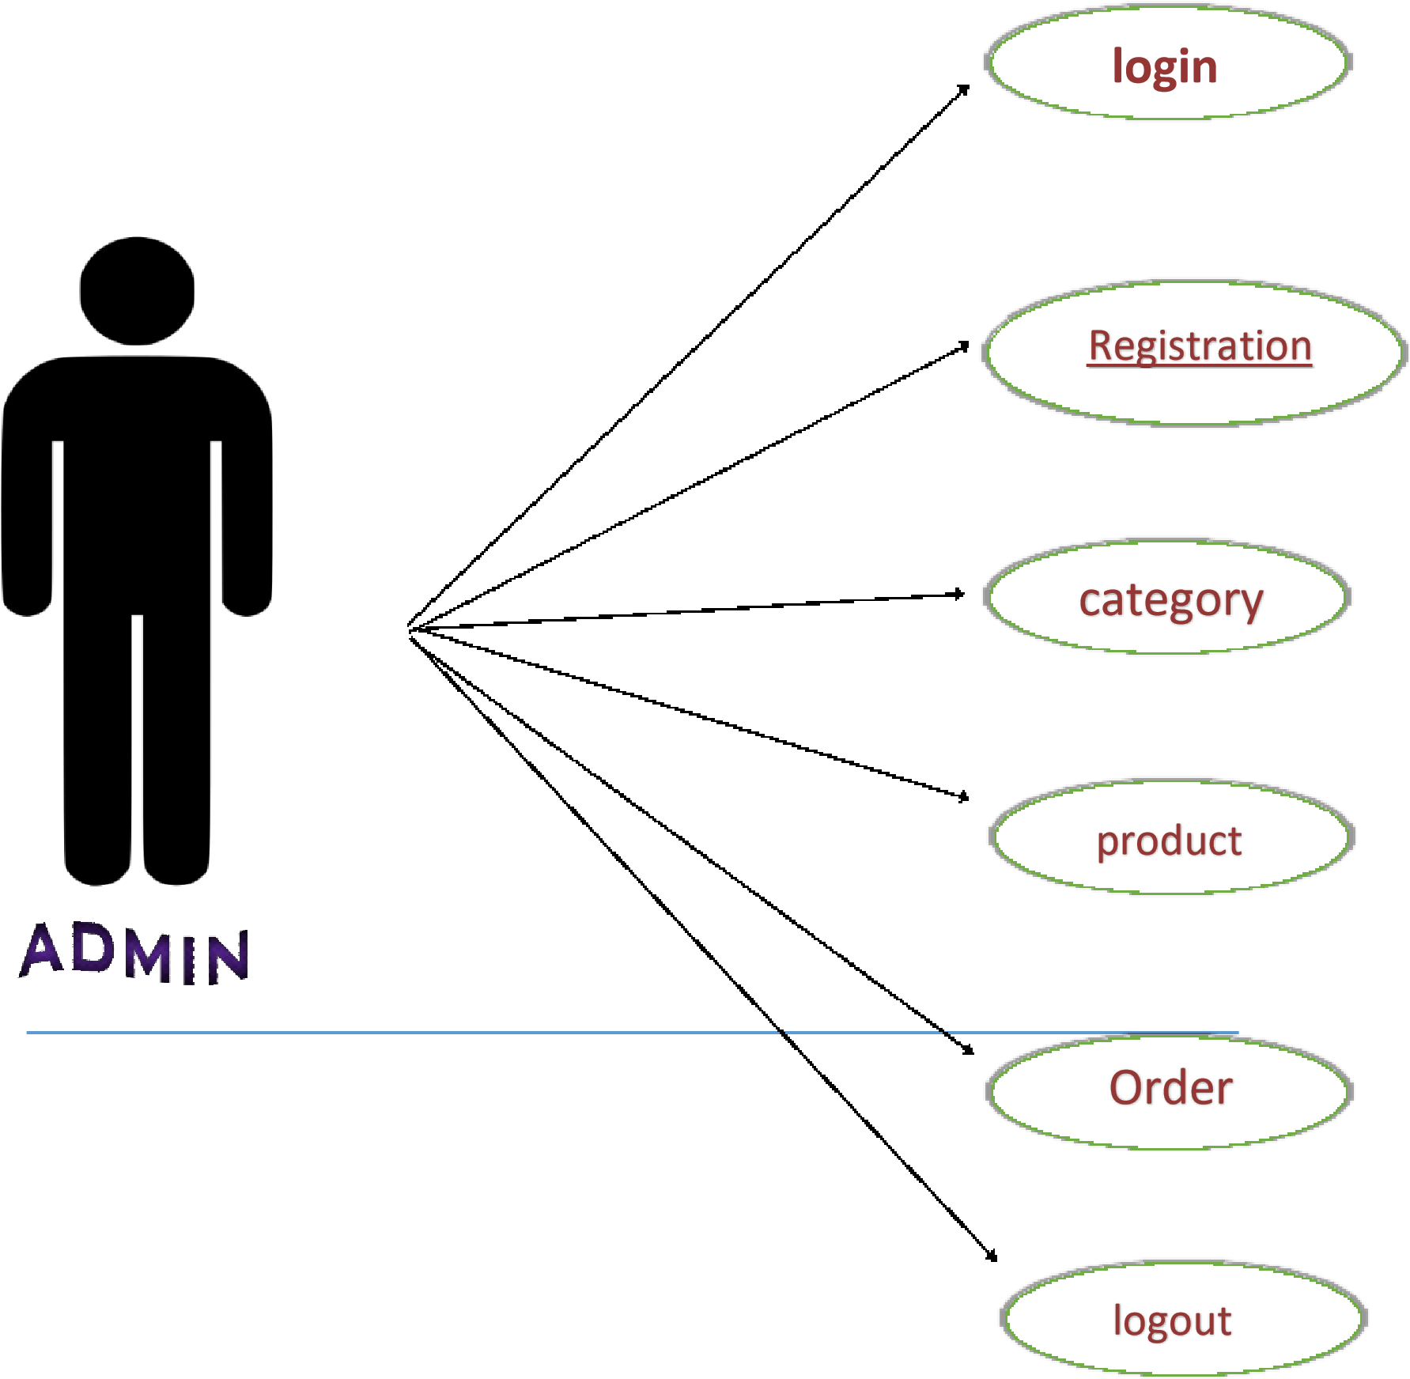

* **USECASE FOR USER:-**

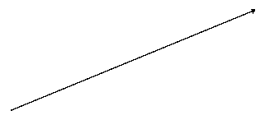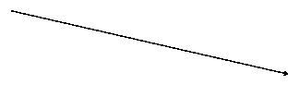

**Registration**



**Login**



**Category**



**View**

**product**



**CLIENT**



**Give**

**order**

* **ACTIVITY DIAGRAM:-**

➢ **ADMIN:-**

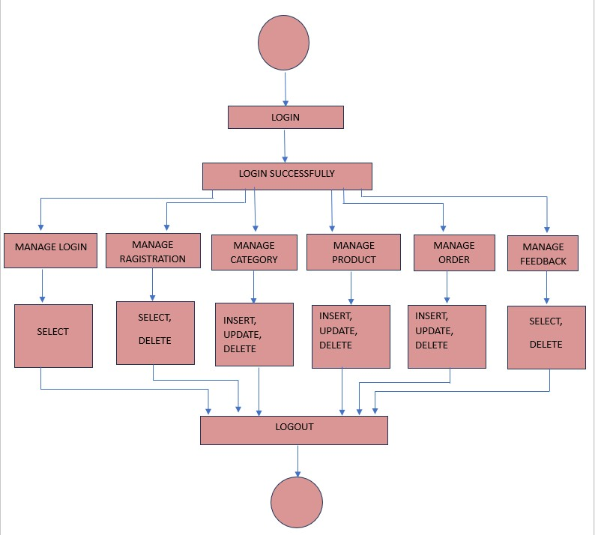

### ➢ CUSTOMER

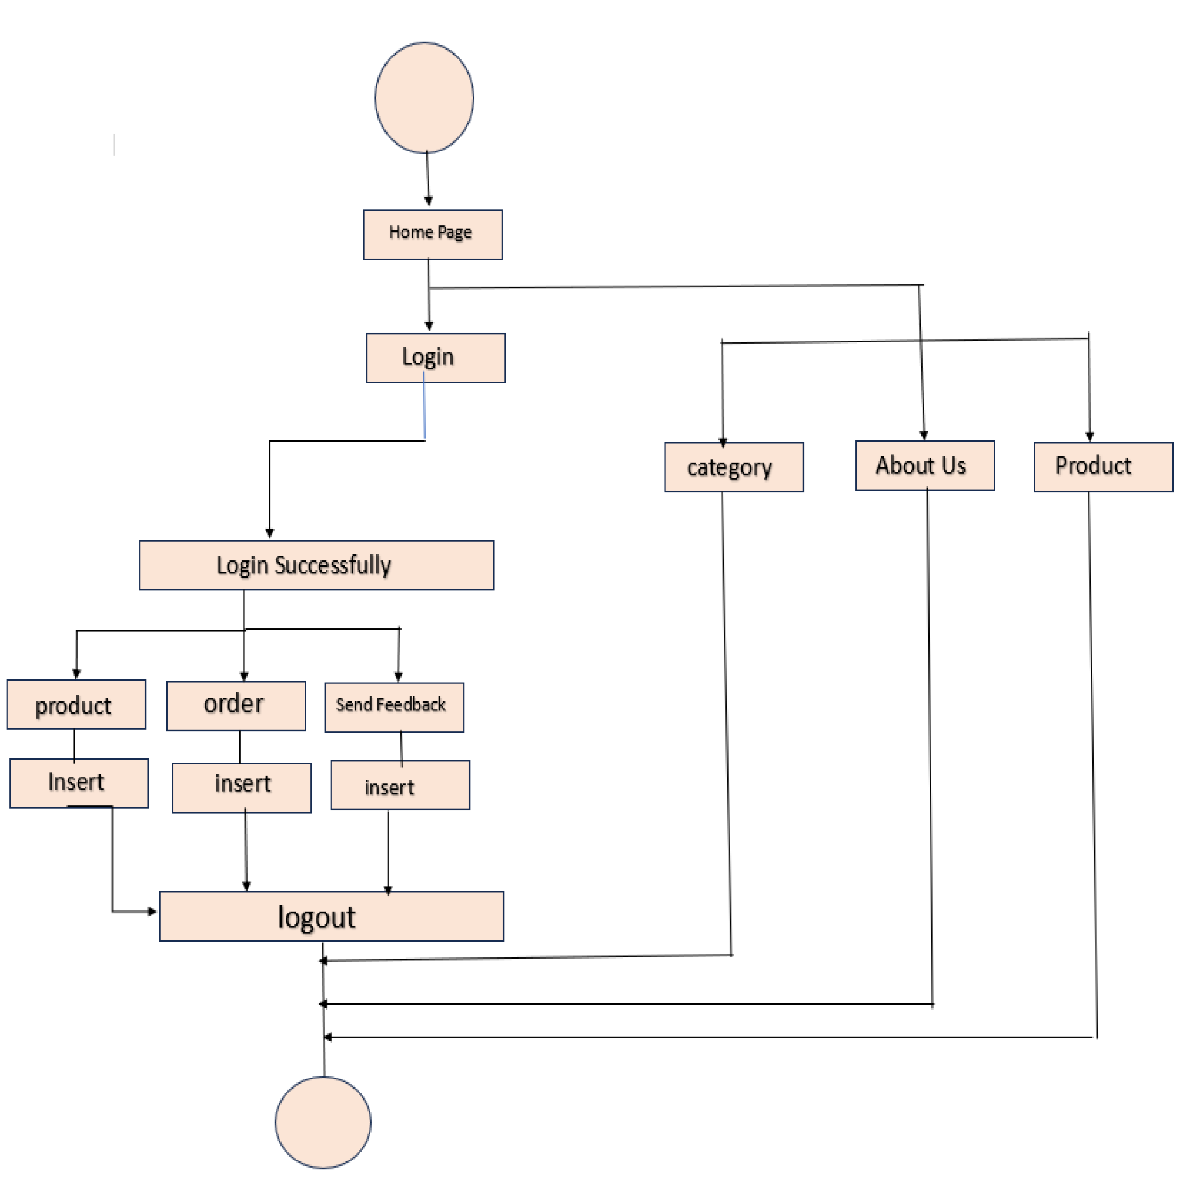

❖ **SYSTEM DESIGN**

➢ **ADMIN SIDE DESIGN**

* **LOGIN MANAGE ADMIN PAGE**

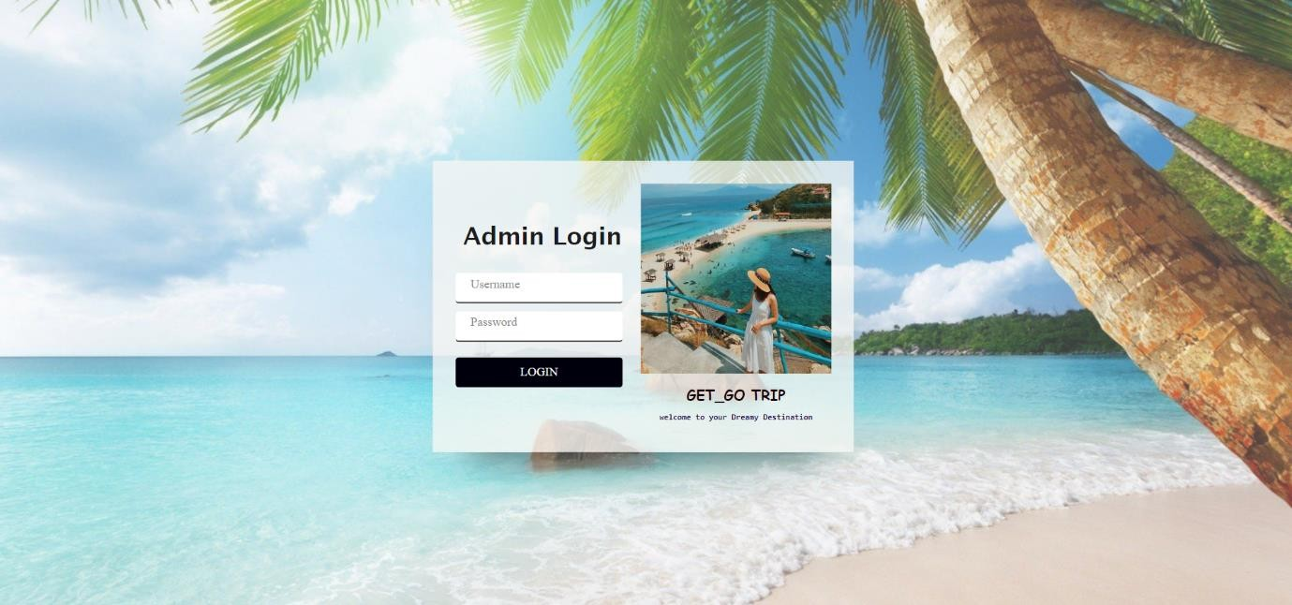

* **DASHBOARD PAGE**

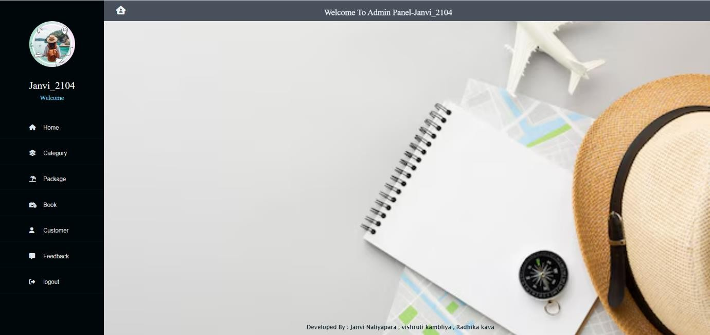

* **MANAGE CATEGORY PAGE** 

 

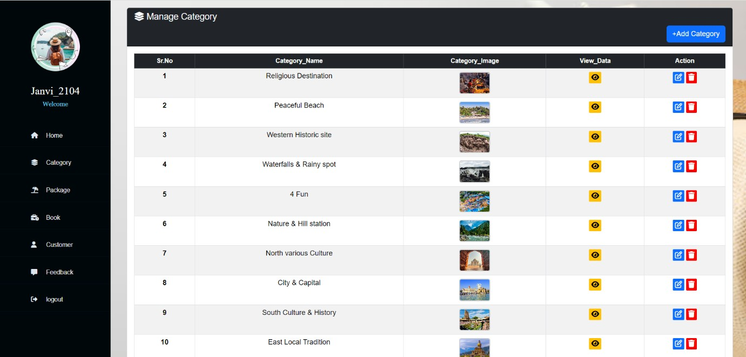 

* **MANAGE PACKAGE PAGE**

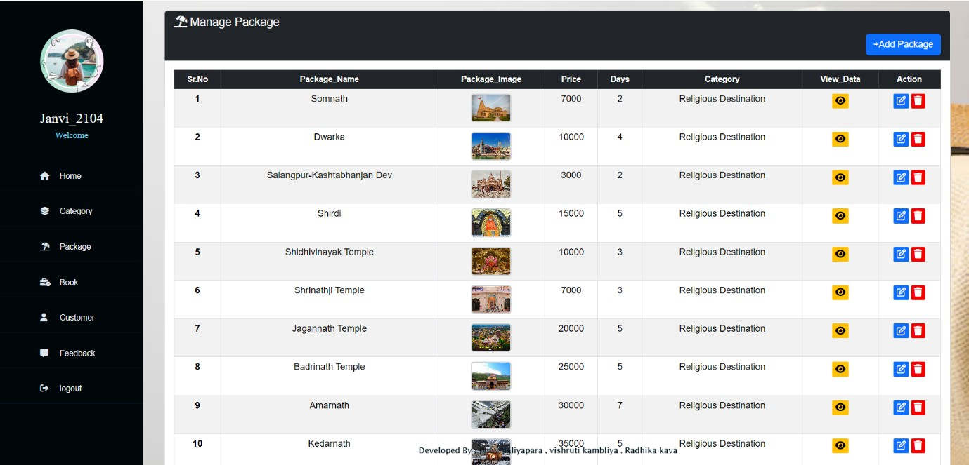

* **EDIT PACKAGE PAGE** 

 

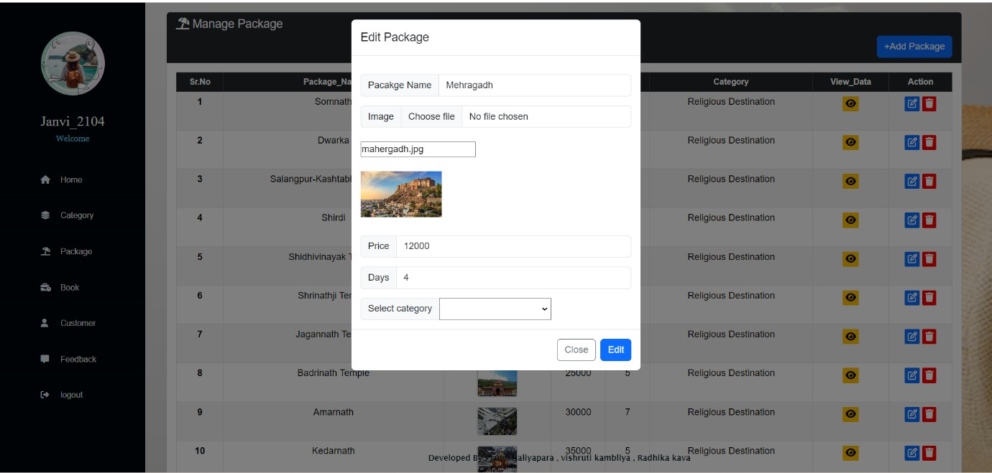 

* **VIEW BOOKING PAGE** 

 

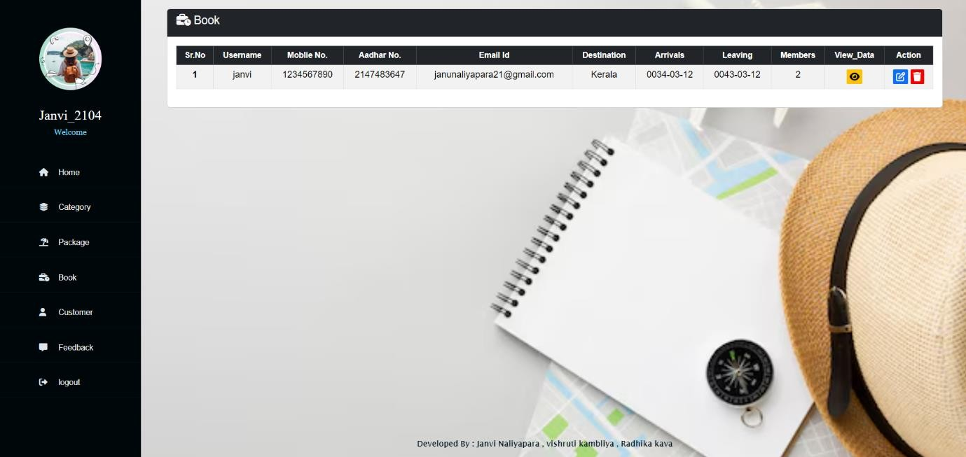  • **VIEW CUSTOMER PAGE**

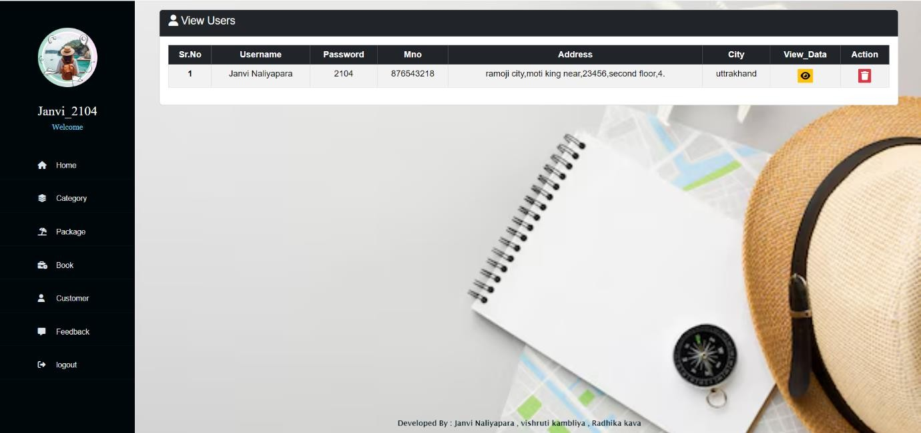

* **VIEW FEEDBACK PAGE** 

 

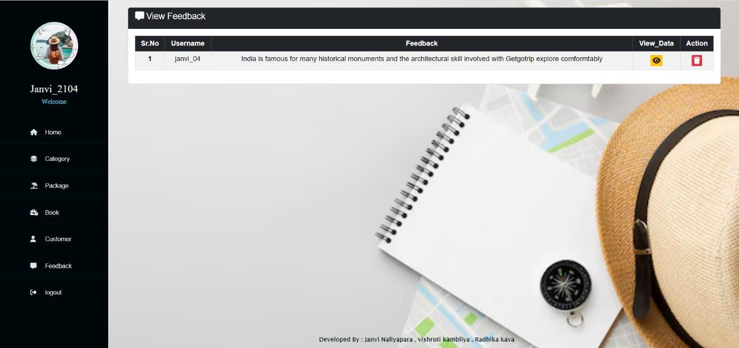  ➢ **CLIENT SIDE DESIGN**

* **HOME PAGE**

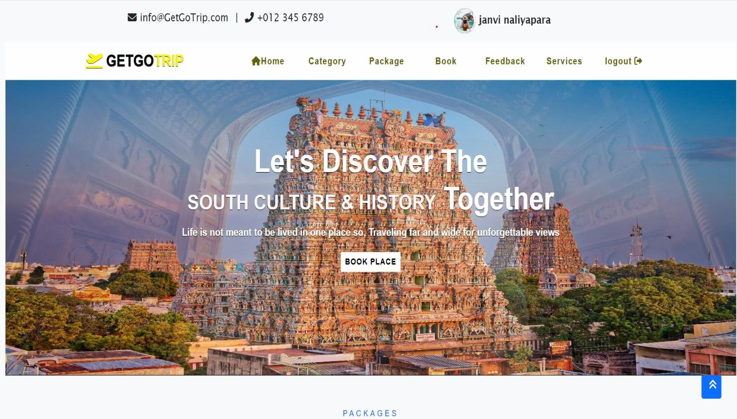

* **CLIENT REGISTRATION PAGE**

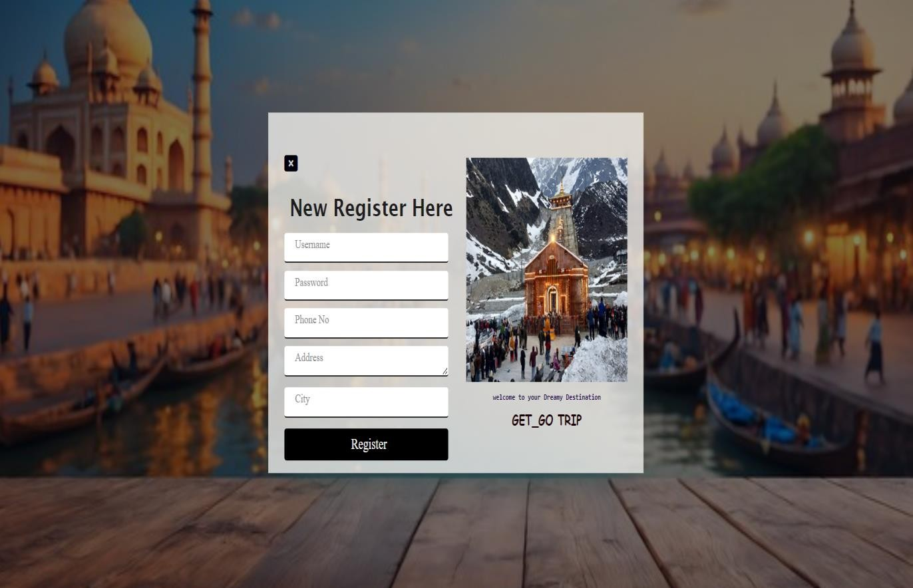

* **CLIENT LOGIN PAGE**

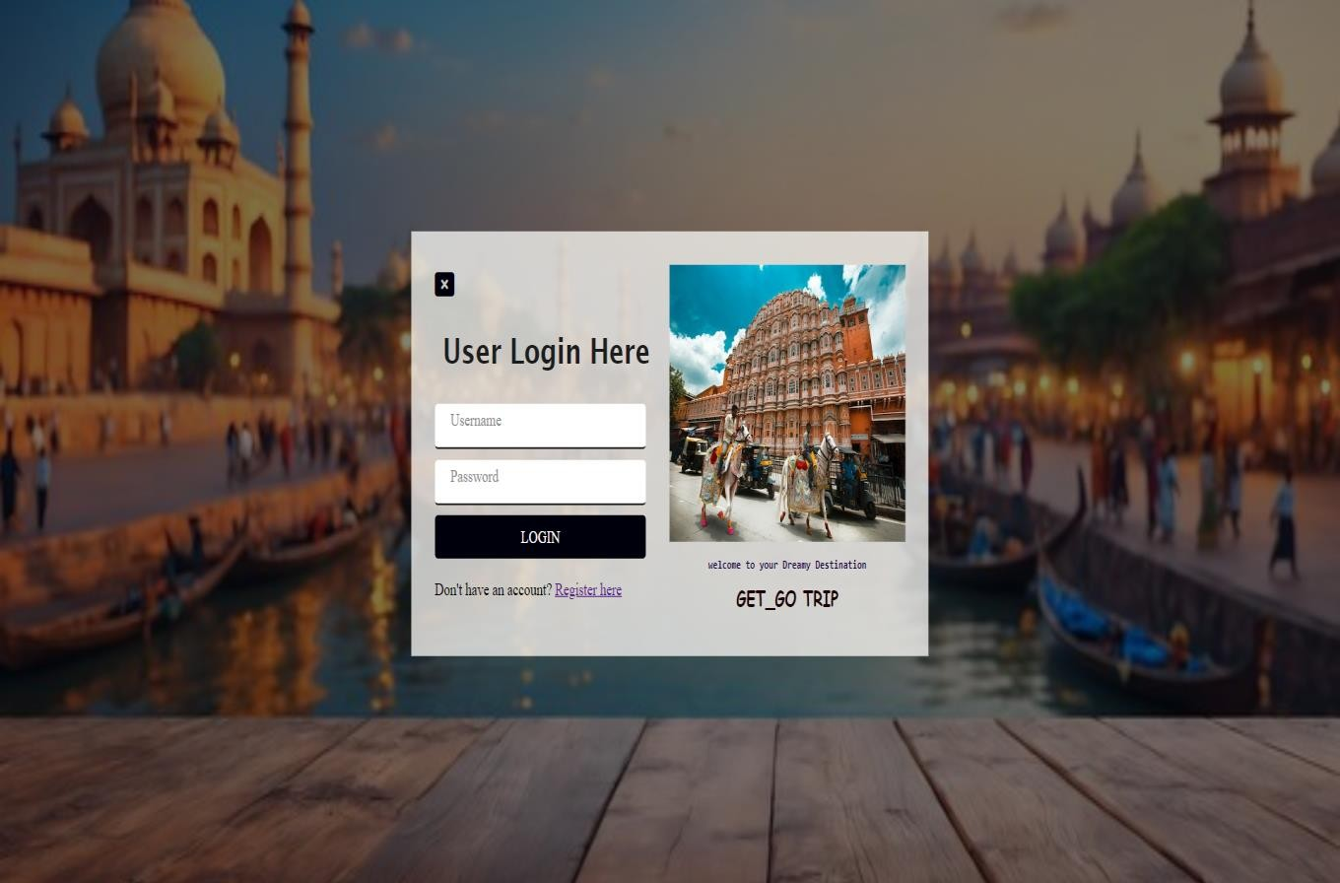

* **VIEW ALL CATEGORY PAGE**

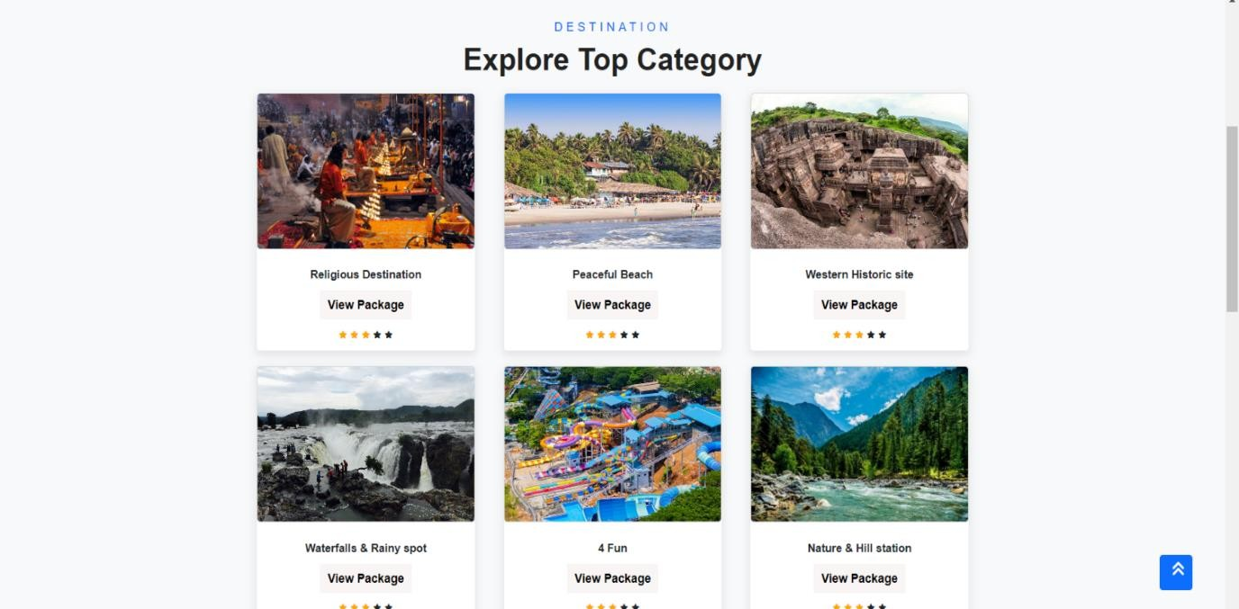

* **VIEW ALL PACKAGE PAGE**

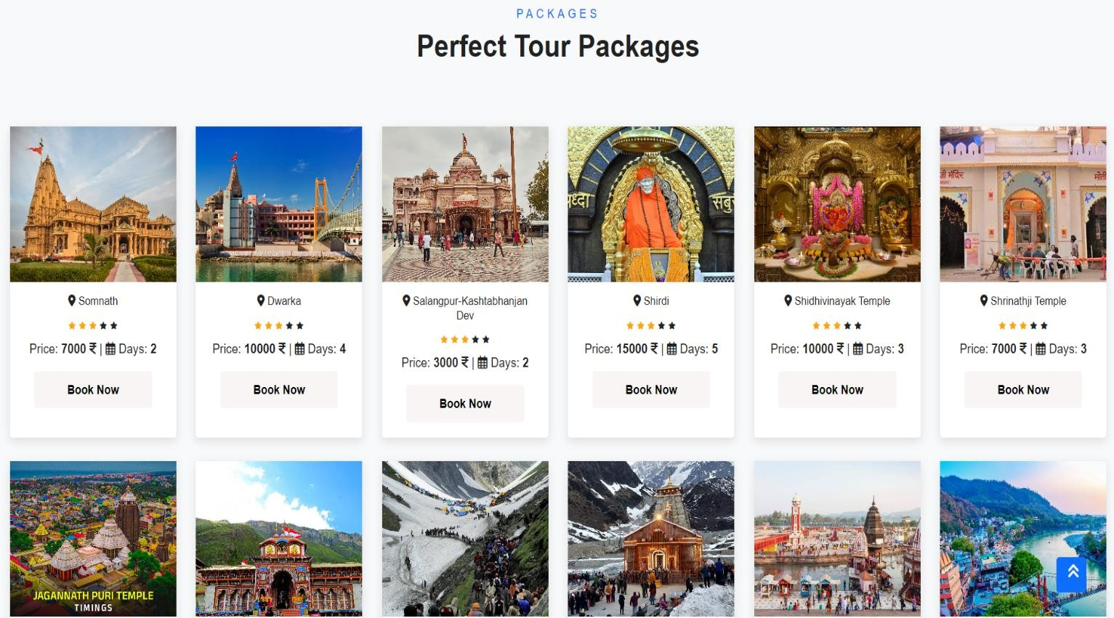

* **VIEW BOOKING PAGE**

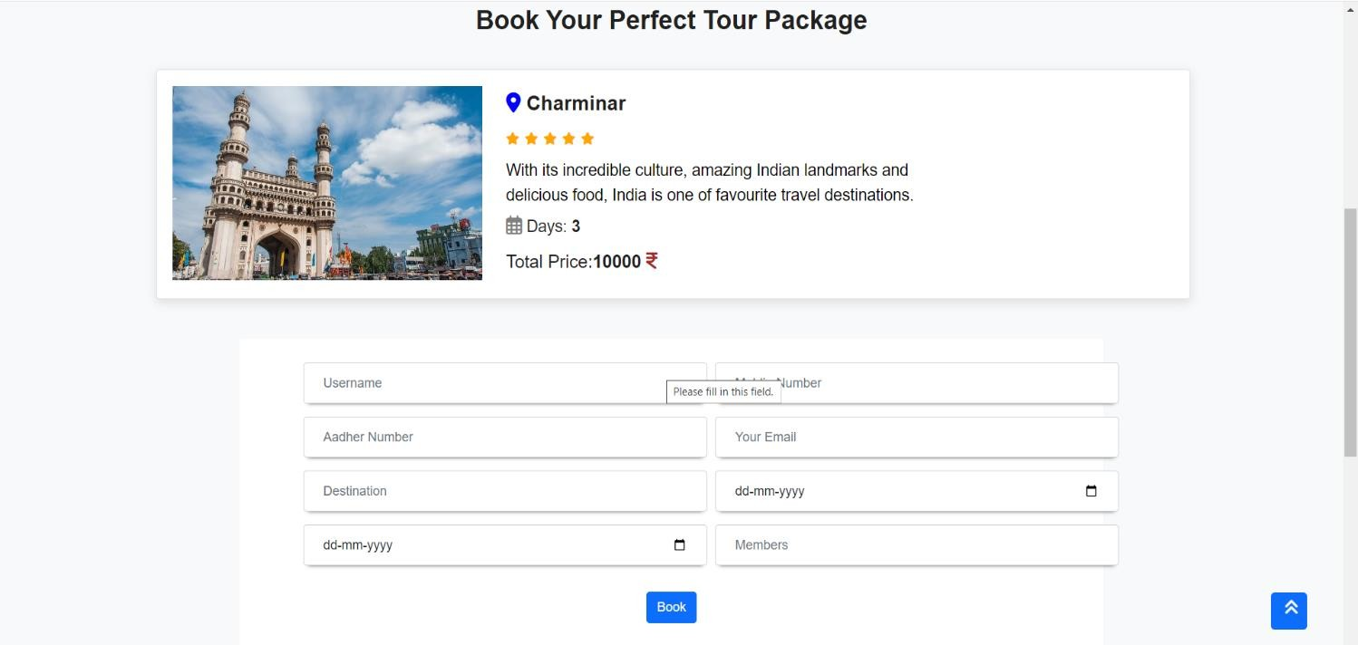

* **VIEW FEEDBACK PAGE**

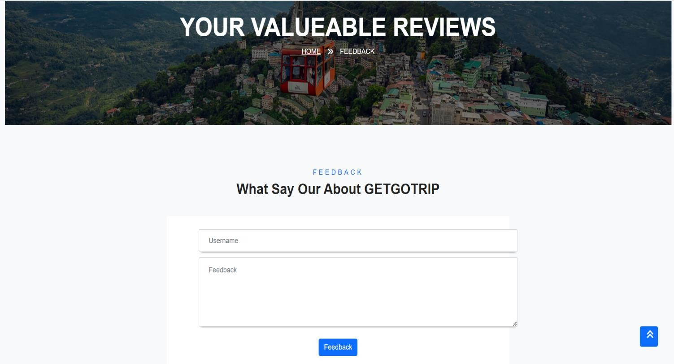

* **VIEW ABOUT US PAGE**

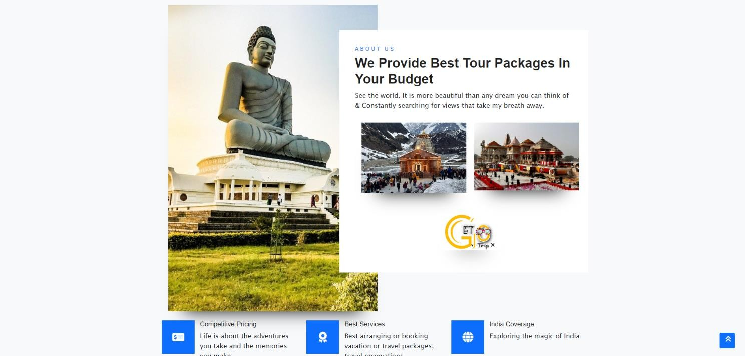

* + - **TESTING**

**Testing is the critical element of software quality assurence & represents the ultimate review of specification design and code generation.**

* + - **MANUAL TESTING**
* **TEST CASE** 
  + **Login**

|  |  |  |  |  |  |  |
| --- | --- | --- | --- | --- | --- | --- |
| **Case no.** | **Scenario** | **Sr.no** | **Action** | **Expected output** | **Actual output** | **Result** |
| **1** | Login | A | User forgets to  enter the username /password | Message window saying “please enter the  username/password” | Message window saying “please enter the username/ password | PASS |
|  |  | B | User enters wrong  username  /  password | Message window saying “Wrong username/password” | Message window saying “Wrong username/ password” | PASS |
|  |  | C | User enters  correct  username  /  password | Takes user to  Homepage | Takes user to  Homepage | PASS |

**⮚ Registration**

|  |  |  |  |  |  |  |
| --- | --- | --- | --- | --- | --- | --- |
| **Case no.** | **Scenario** | **Sr.no** | **Action** | **Expected Output** | **Actiual Output** | **Result** |
| **2.** | Registration | A | User enters wrong email format | Message window saying “email should contain @” | Message window saying “email should  contain  @” | **PASS** |
|  |  | B | User does not  enters Some  record e.g.  name | Message window saying  “Name  Should Not be null” | Message window saying “Name  Should Not be null” | **PASS** |
|  |  | c | User enters wrong passwor  d in confirm passwor d | Message window saying  “password do not match” | Message window saying  “password do not match” | **PASS** |

* **CONCLUSION**

THE **TOUR PACKAGE BOOKING SYSTEM** PROJECT is an online web application where the customer can purchase.

Through a web browser the customer can search for a product by its title or Author later can add to Booking and finally purchase the product.

We think that our project has all the features that are required for an

THE BANK MANAGEMENT SYSTEM

Also we think that the user interface that we provide is quite user friendly and simple.

* **BIBLIOGRAPHY**

## ➢ Website referred:-

[Booking.com](https://www.googleadservices.com/pagead/aclk?sa=L&ai=DChcSEwj_-fXR-t6IAxUgG4MDHdoqC_gYABAGGgJzZg&co=1&ase=2&gclid=CjwKCAjw6c63BhAiEiwAF0EH1HuMpm7IQFv8s6RkoUuZBxRibJNXnR8CyU5TrH3ILGbAv9QcEcCgCRoCEPMQAvD_BwE&ohost=www.google.com&cid=CAESVuD21UXkoFRBqdYrID5pp5uZ-fLmCso0y6-Mx_gFStozkZnqQvg3AoiA1TRyYuRvMX3DNJuP0_aPamfnQvZO4dcMR83OevvZEFCN7kyKBWXXTHjJoC0A&sig=AOD64_0iVtPfW3OGvUDqB-TVE6TO0kWpBw&q&nis=4&adurl&ved=2ahUKEwjhrPDR-t6IAxXVe2wGHYRLEJcQ0Qx6BAgbEAM)

https://www.yatra.com

[https://www.makemytrip.com](https://www.makemytrip.com/)

https://www.holidify.com

[https://www.myholidays.com](https://www.myholidays.com/blog/stunning-places-to-visit-in-india/)

### https://traveltriangle.com

❖ **PROJECT TASK REPORT**

Project Name:- “APPS STORE”

Faculty name:- Prof. JP VYASS

Student Name:- MANDAVIYA ANKIT

BHALANI JENISH

KINDERKHEDIYA VASU

|  |  |  |  |  |  |
| --- | --- | --- | --- | --- | --- |
| **Sr.no** | **Start date** | **End date** | **Project Task** | **Faculty sign** | **Student sign** |
| **1** | 01-07-2024 | 15-07-2024 | Requirement Gathering |  |  |
| **2** | 16-07-2024 | 22-07-2024 | Analysis |  |  |
| **3** | 23-07-2024 | 28-07-2024 | Database Design |  |  |
| **4** | 29-07-2024 | 29-08-2024 | System Design & Coding |  |  |
| **5** | 30-08-2024 | 10-09-2024 | Testing |  |  |
| **6** | 11-09-2024 | 25-09-2024 | Documentation |  |  |